UNIT 1 – MICROECONOMICS

DATA INTERPRETATION AND EXTENDED ANSWER QUESTIONS

Contents 1
Examination Technique 2
Syllabus bullet points and questions
- Topic 1 – Markets 4
- Topic 2 – Demand and Supply 5
- Topic 3 – Elasticity 6
- Topic 4 – Efficiency 9
- Topic 5 – Market failure 10
- Topic 6 – Government Policy 12

Essential points 14
Answer section 20

Note about answers provided for Extended Answer questions
Suggested answers to Extended Answer (Section C) questions are provided in different forms in this booklet.
- Menu style essay plans – main points of answer are listed under various categories
- Flow-chart style essay plans – a sequence of main paragraphs is provided
- Outline full written answer form
- Full written answer form

Develop the skill of translating one form to another, e.g. a menu-style plan to a flow chart style plan. You may not have time to write out too many full answers but you should do some.
EXAMINATION TECHNIQUE
Data interpretation
Each question is based on stimulus material that can include graphs, tables and/or text.
Each question has between three and five parts.
Questions can require the candidate to refer to and/or use the stimulus material to:
- Perform calculations
- Identify, describe and/or account for trends
- Identify, discuss and/or explain relationships
Questions can require the candidate to apply economic concepts, theories and/or models.

In your answers you should:
- Refer to the stimulus material wherever possible.
- When asked to describe movements or trends in data state high and low turning points, and calculate absolute and percentage changes where possible.
- Define and describe the meaning of economic terms
- Use the number of marks available for each section to judge how many points to make in your answer

Extended Answers
Questions can be in the form of an essay or in sections.

Command words: Questions will include one or more ‘command’ or ‘task’ or ‘key’ words that indicate the approach that should be taken in answering the question. Answer the question that has been set following the approach suggested by the command word(s).
Outline | Give a brief account or summary. Set out the main characteristics.
State | Express in clear terms.
Define | Specify meaning.
Describe | Give a detailed account of the features of something without interpreting the information
Apply | Use an economic concept, principle, theory, law, model or idea in relation to a given problem or issue
Demonstrate  Show that | Obtain the information required (possibly using information given) without the formality of proof. ‘Show that’ questions do not generally require the use of a calculator.
Explain or  account for | Give a detailed account including reasons or causes
Discuss | Offer a considered and balanced view that includes a range of arguments or factors. Opinions or conclusions should be presented clearly and supported by appropriate evidence.
Examine or  Evaluate or  Assess or  comment on | Investigate closely - present and give an informed, balanced judgement on the value of arguments for and against. Consider all angles. Criticise in terms of impact and investigate the implications

Anticipate the mark scheme: Work out where the marks will be allocated – what is the examiner expecting to see?

Make a plan: A plan provides structure. Build your structure using frameworks or lists that you have used in your studies. Write down or sketch your plan – it doesn’t have to be neat - only you have to be able to read it. It is not a waste of time – research shows that, without reference to a plan, students stray away from the question they are meant to be answering.

Ingredients of your answer (and hence your plan)
- Definitions – off all economic terms in the question and terms you introduce
- Scaffold or framework – see below
- Time allowance (in an exam write out starting and finishing times)
- Key terms
- Memory prompts for your main points (or body paragraphs)
- Diagrams or models (see below)
- Conclusion / Evaluation point

Stick to a simple, efficient style: Introductory paragraph: Define all economic terms. Add a short comment about relevance of issue to real life or the current situation. Alert the reader, briefly, to the framework of your answer (e.g. saying that there are three causes). Body paragraphs: Make your main points in short three sentence paragraphs (see below) starting each with words like firstly, next, finally etc. to show you are moving on to a new point idea.

Three sentence (SEE) paragraphs: Typically, use three sentences in each paragraph.
 | Purpose | Example
S | State the point. | The first component of aggregate demand is consumption expenditure.
E | Explain / describe further | Consumption is spending by households on goods and services and makes up about 55% to 60% of total expenditure.
E | Give an example | For example, households buying groceries or electrical equipment are undertaking consumption spending.

Diagrams: In many cases (if there are several marks on offer) you can add value to your answer using a diagram or economic model. Examiners like diagrams to be clear and reasonably sized. Draw them using a pencil and ruler or straight edge. Label axes and all lines/curves. Highlight key points on the axes and movement of lines. Integrate your diagram in your text - not as an add-on at the end. Explain the key points of the diagram and what it shows.

Review
1. Read question. Re-read the question!  2. Check ‘command’ word(s)  3. Anticipate where you will earn your marks  4. Plan before you start writing  5. Watch the clock! Plan (and write down) when you have to finish each section and move on) | 6. Design or recall framework to give structure to your answer  7. Write in a simple efficient style  8. Use economic terminology  9. Draw diagrams (and add short explanation of what it shows and why you drew it)  10. Make your answer pleasing to read.
TOPIC 1 – MARKETS
Syllabus bullet points
- The characteristics of a market economy
- The distinction between product and factor markets
- The distinction between competitive and non-competitive markets

Question 1 – Data Interpretation

Claremont Quarter

(a) Why are the products in these David Jones and Coles store ‘for sale’ and not offered free of charge? (2 marks)
(b) What are the main characteristics of the market activity that takes place within these shops? (4 marks)
(c) Explain when the separate markets offered by these shops are in equilibrium and when they are in disequilibrium. (6 marks)

Question 2 – Data Interpretation
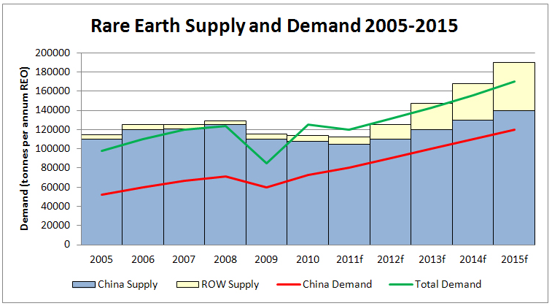
Rare-earth metals, such as cerium and promethium, are a vital factor of production used by all industries that make use of rechargeable batteries, solar cells and strong magnets.
Currently, China produces about 97% of the global supply of rare-earth metals. Most of China’s exports of rare-earth metals are bought by the United States and Japan.

In 2010, the Chinese government ordered China’s mining companies to cut exports of rare-earth metals by 35%. The United States and Japanese governments immediately accused China of exercising monopoly power at their expense. China’s monopoly power is strengthened by the fact that demand for rare-earth metals is relatively price inelastic. Forcing up the prices of rare-earth metals in other countries currently gives China an artificial competitive advantage in world markets for high technology manufactured goods

(a) Define the term ‘factor of production’ and identify the different types of factors of production available in an economy (3 marks)
(b) Comment on the trends in demand and supply for rare-earth metals shown in the chart, and describe the relationship between them. (4 marks)
(c) With the help of an appropriate diagram explain how China can increase the prices of rare-earth metals by using monopoly power. (5 marks)

Question 3 – Extended Answer Question
(a) Describe the main features of a market economy (12 marks)
(b) Describe four situations were a market economy does not lead to an efficient allocation of resources. (8 marks)

TOPIC 2 – DEMAND AND SUPPLY
Syllabus bullet points
- The law of demand
- The relationship between individual and market demand schedules and curves
- Factors affecting demand: Price, Income, Population, Tastes and preferences, Prices of substitutes and complements, future price expectations.
- The effect of changes in price on quantity demanded i.e. expansion or contraction of demand
- The effect of changes in non-price factors on quantity demanded i.e. increase or decrease in demand
- The law of supply
- The relationship between individual and market supply schedules and curves
- Factors affecting supply: Price, Costs of production, Factors of production, Expected future prices, Number of suppliers, Technology
- The effect of changes in price on quantity supplied i.e. expansion or contraction of supply
- The effect of changes in non-price factors on quantity supplied i.e. increase or decrease in supply
- The concept of market equilibrium
- The effect of changes in demand and supply on market equilibrium
- The concepts of market clearing, shortages and surpluses
- How the price mechanism clears market surpluses and shortages

Question 1 – Data Interpretation
CASE STUDY – SUPERFOODS
Consumers in the developed world are increasingly demanding so-called ‘superfood’ products produced in the developing countries such as Peru, Bolivia and Ethiopia. These superfoods include grains or seeds, such as Chia, Quinoa and Teff, berries, such as Ącaí, Goji and blue berries, and vegetables such as kale and broccoli, and coconut water.

Superfoods are generally highly nutritious containing lots of fibre, vitamins, protein, minerals and antioxidants amongst other things, but, on their own, are not particularly appetizing or tasty. They have become fashionable among people looking for a ‘silver bullet’ or easier and more interesting way of staying healthy than sticking to a balanced diet and taking regular exercise.

Demand for some of these products has grown as a result of favourable scientific research and publicity (Chia seed) and from reports that their consumption has transformed peoples’ health.
Demand for other superfood products has grown because of celebrity endorsement including Oprah Winfrey (Ącaí berries) and Michelle Obama (Quinoa) and, as a result, have become highly fashionable.

As a result of increased demand prices of these products have risen sharply. For example, the price of Quinoa was $300/ton five years ago but is now $1,500/ton.

The surge in demand is not good news for everybody in the countries where the products are grown, especially if the crops are perishable and form part of the local staple diet. While in the short term a surge in export sales means higher prices for the growers, they also mean local consumers can become priced out of the market. Indeed, Ethiopia currently has a ban on Teff grain exports.

In the longer term, prices may fall back. Higher prices encourage investment in new land and production techniques to increase supply. Also, fashions can change and demand for today’s popular crops can fall away as different substitute superfoods are discovered.

(a) Define the terms demand and supply. (2 marks)
(b) Identify four non-price factors affecting the demand for superfoods. (4 marks)
(c) Using demand and supply analysis, explain the price movements in the market for one or more superfood products.

Question 2 – Extended Answer Question
Assume that, because of an improvement in the quality and taste of tap water, there is a decrease in the demand for bottled water. Describe in detail the process through which a new equilibrium will be established in the market for bottled water. (20 marks)

TOPIC 3 - ELASTICITY
Syllabus bullet points
- The concept, and measurement, of price elasticity of demand
- Determinants of price elasticity of demand
- The distinction between goods that are price elastic and price inelastic in demand
- The link between price elasticity of demand and total revenue
- The concept, and measurement, of income elasticity of demand
- The behaviour of normal goods and inferior goods in response to changes in income
- The concept of cross elasticity of demand
- The significance of substitute and complementary goods in relation to price, income and cross elasticities of demand
- The concept of price elasticity of supply
- The distinction between goods that are price elastic and price inelastic in supply
- Determinants of price elasticity of supply
- The significance of price and income elasticity for consumers, business and government

Question 1 – Data Interpretation
Price discrimination happens when a supplier sells the same product to different customers at different prices. For price discrimination to take place:
- The producer must have some degree of ‘price making’ power
- Different customers must have different levels of price elasticity of demand
- The producer must be able to detect each customers level of price sensitivity
- The producer must be able to prevent market seepage or resale between customers

Uber operates in the ‘ride-hailing’ (taxi) market in over 425 cities in 70 countries through a smartphone app used to summon cars. Uber doesn’t own any cars directly. It pockets, on average, about 25% of the fares paid to the drivers or owners or cars summonsed on the smartphone app. Uber operates a system of dynamic or surge pricing. This pricing strategy is a version of price discrimination where prices are flexible and vary according to the current market situation. Uber fares rise automatically when the demand for cars is higher than the supply of cars near to the customer.


When customers open the Uber app, they are shown a ‘surge price multiplier’ such as 1.7 or 2.3 times the standard fare before they call for a car. Typically prices surge in the morning and evening peak periods, increase a little at lunchtime but rarely in mid-morning, mid afternoon and the evening. The price surge ensures taxis are available for those who agree to pay a bit more by putting off some price sensitive customers and encouraging more drivers to get on the road and head to areas of high demand.

The ‘surge price multiplier’ indicator on the app is being replaced by a simpler ‘fares are higher due to increased demand’ notice in some countries and Uber is also removing an option that notifies customers when there is to be a fall in the surge price. Uber believes that hiding the surge price multiplier could stop price sensitive people being discouraged from using the service. Like other forms of price discrimination, dynamic pricing is legal if it not anti-competitive.

(a) What is price elasticity of demand? (1 mark)
(b) Describe three factors that affect the price elasticity of demand for Uber cabs. (3 marks)
(c) Explain why Uber’s surge pricing policy eliminates excess demand for Uber cabs in peak periods. (4 marks)
(d) Using appropriate demand curve diagrams show that car owners’ earn more revenue when they practice price discrimination than when they charge all customers a standard fare. (4 marks)

Question 2 – Data Interpretation
This question refers to the following hypothetical demand and supply data for flowers

(a) Label the demand and supply curves (1 mark)
(b) According to the graph, if the price for flowers increases from $20 to $35 demand would fall from 250 units to 200 units. For this change in price and quantity demanded;
- Calculate the percentage change in price of the flowers. Use either the point method, or mid-point method for your calculation. (1 mark)
- Calculate the percentage change in quantity demanded of the flowers. Use either the point method, or mid-point method for your calculation. (1 mark)
- Calculate the price elasticity of demand for the flowers (1 mark)
(c) Use the ‘revenue test’ to determine whether demand was relatively elastic or inelastic during this price range. Show your working. (2 mark)
(d) Outline three (3) factors that could affect the elasticity of supply for flowers. (6 marks)

Question 3 - Extended Answer Question
(a) Explain why an understanding of price elasticity of demand and cross-price elasticity of demand may be important to a government. (12 marks)
(b) Explain why income elasticity of demand is a useful concept when explaining changes in the share of GDP of the service or tertiary sector in the economy. (8 marks)
TOPIC 4 - EFFICIENCY
Syllabus bullet points
- The concept of efficiency
- The benefits to consumers as market participants, applying marginal benefit and consumer surplus
- The benefits to producers as market participants, applying marginal cost and producer surplus
- The efficiency of market equilibrium i.e. maximising total surplus
- How under and overproduction in a market can result in a deadweight loss

Question 1 – Data interpretation

Total or community surplus reflects the net benefits society obtains from the consumption and production of a particular good or service. It is a way to measure how well the economy is solving the economic problem. Only when total or community surplus is being maximised can it be said that the allocation of resources is efficient.

Total or community surplus is an important concept because it provides economists with a measure of market efficiency. Total or community surplus is the sum of consumer and producer surplus. If resources are allocated in a way that maximises total or community surplus in each market, then the economy’s resources will be used in the best possible way.

Source: Discovering Economics, Kemp and Parry

(a) Define the terms ‘market efficiency’ and the term ‘economic problem’ (4 marks)
(b) On a supply and demand diagram for a market identify (i) the area representing consumer surplus and (ii) the area representing producer surplus. (2 marks)
(c) Explain why market efficiency falls if the quantity actually traded above or below the quantity at market equilibrium. (2 marks)
(d) Describe two situations that might cause too few resources to be allocated to a market. (4 marks)

Question 2 - Data interpretation
Table 1 shows a farmer’s willingness to purchase cows. Table 2 shows the farmer’s demand for sheep dip.

Table 1 |  |  |  | Table 2
Number of cows | Willingness to pay ($) | Consumer surplus |  | Price of sheep dip ($) | Quantity demanded
1st | 100 |  |  | 100 | 1
2nd | 90 |  |  | 90 | 2
3rd | 80 |  |  | 80 | 3
4th | 70 |  |  | 70 | 4
5th | 60 |  |  | 60 | 5
6th | 50 |  |  | 50 | 6
7th | 40 |  |  | 40 | 7
8th | 30 |  |  | 30 | 8
9th | 20 |  |  | 20 | 9
10th | 10 |  |  | 10 | 10
 | TOTAL

(a) When the price of a cow is $60, how many cows will the farmer buy (assuming the farmer buys the break-even cow)? (2 mark)
(b) Complete the third column by calculating the level of consumer surplus the farmer receives for each cow he buys, assuming each cow costs $60. (2 mark)
(c) What is the total level of consumer surplus the farmer receives from buying 5 cows? (2 mark)
(d) Assuming the price of sheep dip is $60 a litre, how much sheep dip will the farmer buy (assuming the farmer buys the break-even litre of sheep dip)? (2 mark)
(e) Calculate the level of consumer surplus the farmer receives from buying 5 litres of sheep dip. (2 mark)
(f) Explain why the answer to (c) and (e) is not the same. (2 marks)

TOPIC 5 – MARKET FAILURE
Syllabus bullet points

Market failure and government policies
- The concept of market failure
- Market power
- The distinction between a competitive and an imperfect market

The concept of market power
- Barriers to entry in a market
- How market power can influence market efficiency i.e. a deadweight loss
- The role of the Australian Competition and Consumer Commission (ACCC) in ensuring market efficiency policy options to influence market power, including regulation/deregulation and legislation

Externalities
- The distinction between positive and negative externalities
- How an externality can influence market efficiency i.e. a deadweight loss
- Policy options to correct for externalities, including the use of taxes and subsidies

Public goods and common resources
- The distinction between public goods and common resources
- Why public goods suffer from the free rider effect
- Why common resources suffer from the tragedy of the commons
- Policy options to reduce market failure associated with public goods and common resources

Equity
- The concept of equity (fairness)
- The relationship between equity and efficiency
- Policy options to promote equity

Question 1 – Data Interpretation
Traffic congestion can impose significant costs on society, interrupting traffic flow, lengthening average journey times, making trip travel times more variable, making vehicle engine operation less efficient, causing higher fuel consumption and reducing air quality so increasing health costs.

The chart shows the actual and projected traffic congestion costs (in cents per kilometre of vehicle use) over time as vehicle use increases.
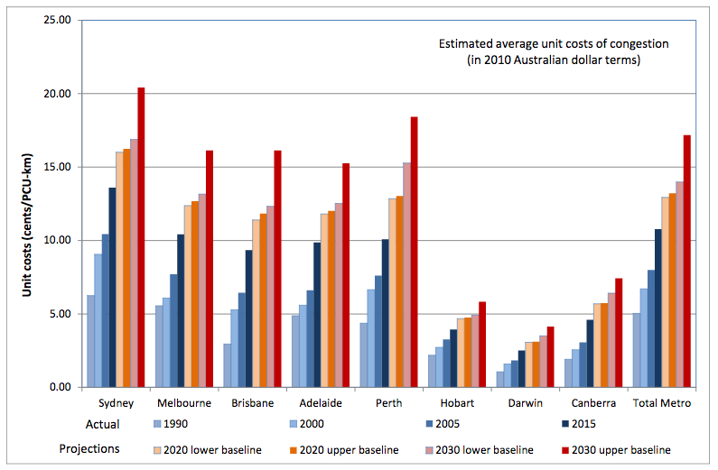

(a) Describe the type of externality that is caused by car use? (2 marks)
(b) Use a demand and supply diagram to show that unregulated use of roads leads to a reduction in welfare (or deadweight loss) (4 marks)
(c) Explain three ways the deadweight loss from traffic congestion can be reduced. (6 marks)

Question 2 – Extended Answer Question
(a) Explain the meaning of the term ‘market power’. (3 marks)
(b) Describe how a firm can acquire market power. (7 marks)
(c) Explain how market power can influence the level of market efficiency. (10 marks)

Question 3 – Extended Answer Question
(a) Describe the market conditions that lead to a ‘tragedy of the commons’ (6 marks)
(b) With reference to a specific example of common access resources that are being overused, suggest two strategies to solving the problem and assess the effectiveness of these strategies. (14 marks)

TOPIC 6 – GOVERNMENT MARKET INTERVENTION
Syllabus bullet points
- The distinction between price ceilings and price floors
- The effects of price ceilings and price floors using consumer and producer surplus
- The effects of a tax on a market
- The effects of a subsidy on a market

Question 1 - Data interpretation

National minimum wage lifted 2.4 per cent after Fair Work Commission ruling

Australia's lowest paid workers will receive a 2.4 per cent pay increase, following the recent annual minimum wage decision. The Fair Work Commission has lifted the national minimum wage from $656.90 a week or $17.29 an hour, to $672.70 a week or $17.70 an hour. It constitutes an increase of $15.80 per week. More than 1.8 million people who are on the minimum wage will receive the increase from July 1.

The commission said a generally robust economic climate provided the opportunity for a modest increase to Australia's lowest paid workers. It said labour market conditions had been stronger over the past year, while inflation and wages growth were at historic lows. The commission noted the relative position of low paid workers had deteriorated over the past 10 years, and that some were living below the poverty line.

Australian Council of Trade Unions (ACTU) secretary David Oliver said the union welcomed the increase, but said it did not go far enough. "If you take into account the inflation rate it delivers a real wage increase of just over 1 per cent," he said. "So for a minimum wage earner, that's something a little over $6 a week."

The Australian Chamber of Commerce and Industry sought a wage increase of no more than 1.2 per cent. Chamber chief executive James Pearson said the increase would be a burden for employers. "In comparison to the 2.4 per cent increase granted by the Fair Work Commission, private sector wages grew by just 1.9 per cent in the year to March 2016," he said in a statement.

Source: www.abc.net.au, accessed 31 May 2016

(a) Explain the meaning of the term ‘price floor’. What is the relationship between the floor price and the market equilibrium price? (2 marks)
(b) Outline the purpose of Australia’s annual minimum wage decision? (2 marks)
(c) Draw a demand and supply diagram illustrating the effect of a minimum wage on a market for low-paid workers. (4 marks)
(d) Explain why the Australian Council of Trade Unions (ACTU) and Australian Chamber of Commerce and Industry hold different opinions about the minimum age decision. (4 marks)

Question 2 – Data Interpretation
Great Southern Land (GSL) celebrates its national day on April 1st. The left wing, socialist government has introduced a law that sets a maximum price for standard chocolate eggs. Standard eggs are a popular gift on GSL’s national day. Demand for eggs is high at this time of year but the official price of a standard egg can’t go above the government’s maximum price.

(a) Explain why the government’s intervention in the free market for chocolate eggs has caused a loss of community surplus and a deadweight loss. (4 marks)
(b) Draw a diagram to show the deadweight loss caused by the minimum price law. (4 marks)
(c) Suggest two reasons why the government might have introduced the maximum price law. (4 marks)

Question 3 – Extended Answer Question
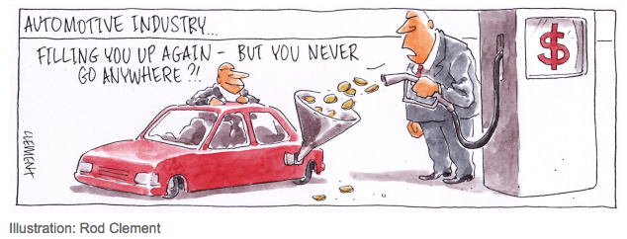

(a) With the use of a demand and supply diagram, describe how the payment of a production subsidy to producers in a market affects market equilibrium in that market.
(8 marks)
(b) By the end of 2017, Ford, Toyota and Holden will have ceased car production in Australia, partly as a result of the withdrawal of production subsidies from these car producers. Firms operating in the broader supply chain are seeking continued government support to help them adapt to the change in circumstances. Describe two benefits and two costs from continuing subsidy payments to car component suppliers in Australia. (12 marks)

Question 4 – Extended Answer Question
(a) Explain the advantages and disadvantages of placing a price ceiling or maximum price for rental property in a town or city. (10 marks)
(b) Explain the advantages and disadvantages of increasing the minimum wage in an economy. (10 marks)

SECTION 2 – ESSENTIAL INFORMATION

ESSENTIAL MARKET ECONOMIES
Meaning of relative scarcity  Limited resources, unlimited wants  Economic goods and free goods: Economic goods are relatively scarce. Free goods are not.  Big choices for all economies  1 What and how much to produce (what?)  2 What resources to use (how?)  3 Who will consume the products (for whom?)  Five characteristics of a market  1 Buyers who create market demand  2 Suppliers who create market supply  3 A commodity or thing that is being sold  4 A process by which buyers and sellers meet  5 A price, reflecting relative strength of market demand and market supply  Seven features of a market economy  1 Property rights and private ownership  2 Economic freedom to enter a market or not  3 Self-interest – maximise satisfaction/profits  4 Competition – restriction of monopoly power  5 Moral hazard – people suffer consequences of their actions  6 Limited role for the government  7 Allocation of resources through the price mechanism  Direct accounting cost and opportunity cost  Accounting costs = cost in dollars (cost of a burger at HJs). Opportunity cost = value of best alternative foregone (benefit foregone of not going to Nandos)  Needs and wants  1 Needs = things you must have for survival  2 Wants = things you would like to have  Priority for satisfying wants  1 Basic survival needs  2 Things that provide security  3 Things that promote social interaction  4 Things associated with respect  5 Things linked to achieving full potential  Four types of resources + examples  1 Land (natural resources)  2 Labour (people in work force  3 Capital (machines, vehicles, equipment)  4 Enterprise (risk takers, business leaders) | Production Possibility Frontier model  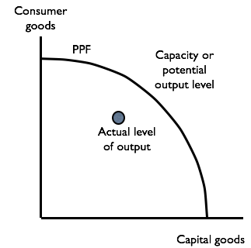  Assumptions  1 Only two products  2 Resource supply is fixed  3 Technology constant  Will be linear or concave when  1 Diminishing marginal returns occurs  2 Increasing cost  Five uses for PPF model  1 Shows opportunity costs  2 Shows potential level of output  3 Shows actual level of output (dot inside)  4 Shows output gap  5 Can show growth with new PPC  Market equilibrium and reallocation of resources  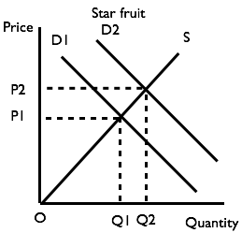  Problems with market economies  1 Externalities  2 Uncompetitive markets (monopoly power)  3 Information gaps (merit and demerit goods)  4 Markets with no price (public goods)  5 Common access resources (tragedy of the commons)  Macroeconomics and microeconomics  Macro = economy as a whole  Micro = separate markets or units within the economy

ESSENTIAL DEMAND, SUPPLY AND EQUILIBRIUM
Law of demand: Inverse relationship between price and quantity demanded.  Inverse relationship between price and quantity  1 Income effect – affect of changing price on level of real income  2 Substitution effect – affect of change in relative prices  Three factors affecting strength of law of demand  1 Availability of substitutes  2 Necessity (urgency) of purchase  3 Proportion of income spent on product  Terms for movement along demand curve  When price increases = contraction in quantity demanded. When price decreases = expansion in quantity demanded  Five non-price factors that affect demand  1 Level of real income  2 Tastes, fashion, preferences  3 Prices of related products (substitutes and complements)  4 Expectations of future price changes  5 Demographic factors (size, age)  Joint Demand: Demand for two or more products is interdependent (e.g. ink cartridges and printers)  Derived Demand: Demand for an intermediate good is dependent on the demand for a final good (e.g. cars and car components)  Composite demand: Products that have more than one use (e.g. oil that can be used to make petrol and plastic) are affected by a combination of factors.  Terms for shifts in demand curve  1 Shift to the right = increase in demand  2 Shift to the left = decrease in demand  Four apparent exceptions to the law of demand  1 High status or Veblen goods  2 Giffen goods (inferior, staple goods such as rice or potatoes)  3 Experience goods (where quality is hard to determine without trying product – value associated with price  4 Bandwagon effects – price change seen as indication of further price changes (e.g. shares) | Law of supply: Direct or positive relationship between price and quantity supplied.  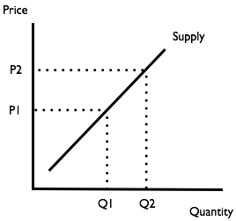  Positive relationship between price and quantity Higher prices mean more profit or ability to cover higher production costs.  Two factors affecting strength of law of supply  1 Time, complexity of the product  2 Availability of spare capacity or stocks  Terms for movement along supply curve  When price increases = expansion of quantity supplied. When price decreases = contraction of quantity supplied  Four non-price factors that affect supply  1 Technology  2 Input costs  3 Government regulations  4 Efficiency of production process  Terms for shifts in supply curve  1 Shift to the right = increase in supply  2 Shift to the left = decrease in supply  One exception to the law of supply  Fixed supply (e.g. sports stadium)  Equilibrium condition: Demand = supply.  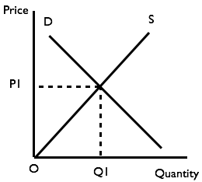  Excess supply: When price above equilibrium (demand < supply).  Excess demand: When price below equilibrium (demand > supply).  Market clearance: When price is at equilibrium level (demand = supply)  Moving from old equilibrium to new equilibrium  1 Market equilibrium is disturbed  2 At existing price there is now a shortage or a surplus  3 Producers change the price to eliminate the shortage or surplus  4 There is a movement along demand and supply curves until market clears again  5 A new equilibrium is established.

ESSENTIAL ELASTICITY
Price elasticity of demand  Price elasticity of demand (PED) is a measure of the response or reaction in quantity demanded to a change in the price of that product.  = Percentage change in quantity demanded  Percentage change in price  Five determinants of PED  1 Is purchase a necessity?  2 Are there any alternatives?  3 How broadly is the market defined?  (Brands more elastic than product as a whole)  4 Time available to respond (urgency)  5 Proportion of income spent on product  Values and terms  PED = infinity: perfectly price elastic  PED = >1: relatively price elastic  PED = 1: unit(ary) price elastic  PED = 0 to 1: relatively price inelastic  PED = 0: perfectly inelastic  PED and Revenue  For price cut, revenue falls when PED demand is price inelastic  For price cut, revenue rises when PED is price elastic  For price cut, revenue stays the same when PED has price elasticity = 1  Revenue can be shown by ‘revenue box’ under demand curve  Income elasticity of demand  Income elasticity of demand (YED) is a measure of the response or reaction in quantity demanded to a change in income.  = % change in quantity demanded  % change in income  Determinants of YED  Quality of product, level of income  Values and terms  YED = positive: Normal product  YED greater than 1: Luxury, income elastic  YED between 0 and 1: Necessity, income inelastic  YED= negative: Inferior product | Significance: Marketing of products, household budgeting, structural change.  Cross price elasticity of demand  Cross-price elasticity of demand (XED) is a measure of the response in demand for a product when the price of a related or linked product changes.  = % change in the demand for product A  % change in the price of product B  Two determinants of XED  1 Are products close substitutes  2 Can consumer swap?  Values and terms  XED = high, positive: close substitutes  XED = low, positive: remote substitutes  XED = 0 = products independent  YED = low, negative: remote complements  YED = high, negative: close complements  Significance  Helps determine size of market and level of competition for producers  Price elasticity of supply  Elasticity of supply is a measure of the reaction or response of a firm in quantity supplied to a market following a change in price of the product  = % change in quantity supplied  % change in price of the product  Four determinants of PES  1 Time period  2 Technical complexity  3 Ability to hold stocks  4 Amount of unused capacity  Values and terms  PES = 0: perfectly supply inelastic  PES = 0 to 1: relatively supply inelastic  PES = 1: supply elastic is unitary  PES > 1: relatively elastic  PES = infinity: perfectly elastic  Significance  Inelastic supply leads to big fluctuations in price (e.g. agricultural markets, housing)

ESSENTIAL MARKET EFFICIENCY
Why is economic efficiency important?  Economic problem is unlimited wants and limited resources. Need to make best use of resources available.  Three types of efficiency  1 Productive or technical efficient = lowest unit cost without loss of quality  2 Allocative efficiency = producing products consumers want (marginal benefit = marginal cost)  3 Economic efficiency = productive + allocative efficiency  Two conditions needed in a market to maximize efficiency  1 Competition (absence of monopoly power)  2 Absence of externalities (side-effects on third parties)  Definition / Meaning of consumer surplus  Marginal benefit is greater than price paid  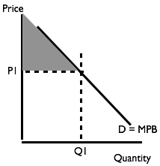  Definition / meaning of producer surplus  Price received greater than marginal cost  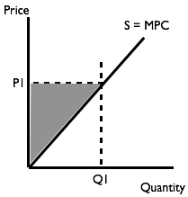  Consumer surplus + producer surplus = Community surplus (total welfare) 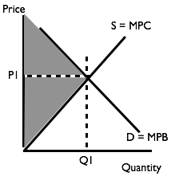 | Definition / Meaning of Deadweight loss  Deadweight loss is the difference between the actual level of welfare generated in a market and the maximum level of welfare possible.  Five situations when deadweight loss occurs  1 When there is under or over production  2 When there is monopoly power  3 When there are externalities  4 When goods are non-rival and/or non-excludable  5 When there are indirect taxes and subsidies that are not correcting other market failures  Under-production Over-production  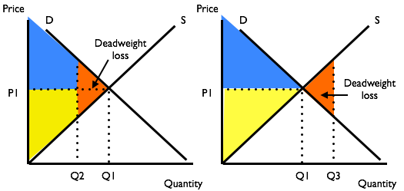

ESSENTIAL MARKET FAILURE
Definition or meaning of market failure  Free market causes an inefficient allocation of resources so total welfare or community surplus is not maximized.  What is monopoly market power?  Ability to influence price and/or quantity of output  Problems with monopoly power  1 Firms raise prices and reduce quantity  2 Loss of consumer surplus, increase in producer surplus, overall deadweight loss  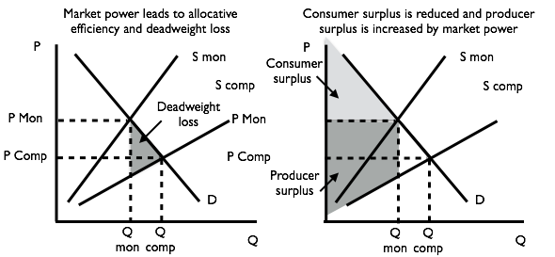  Two problems with information gaps  1 People don’t make rational decisions  2 May ignore impact of externalities  Two characteristics of merit goods  1 Benefits not understood or ignored and positive externalities ignored  2 Under-consumed  Two characteristics of de-merit goods  1 Costs not understood or ignored and negative externalities ignored  2 Over-consumed  Externality  Side-effect - affect on bystander or third party.  Four types of externality  1 Positive consumption externality (e.g. flu jabs, education)  2 Negative consumption externality (e.g. passive smoking, noise pollution)  3 Positive production externality (e.g. training, renewable energy)  4 Negative production externality (e.g. pollution)  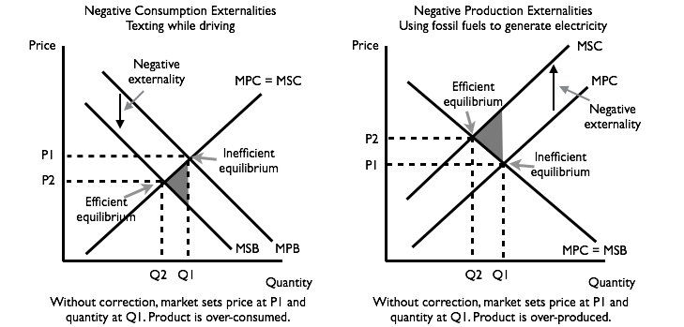 | 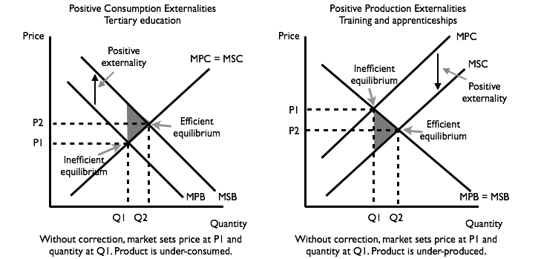  Triangle always points to most efficient point.  Solutions for externalities  1 Tax bad behaviour, subsidise good  2 Regulate  3 Educate  Rival and Non-Rival  1 Rival – consumption by one person prevents consumption by another  2 Non-rival – collective consumption possible  Excludable and Non-Excludable  1 Non-excludable – benefits of product can be withheld – everybody can access benefits  2 Excludable – non-payers can be excluded from benefits  Four types of product based on rival and excludable features  1 Private goods (rival and excludable)  2 Common property or access resources (non-excludable, possibly rival)  3 Public good (non-rival, non-excludable)  4 Natural monopoly or club good (non-rival, excludable)  Problems with public goods  Under-provision. There is no market.  Solutions:  1 Government provision  2 Public-Private partnerships  Problem with common access resources  Tragedy of the commons, over-exploitation.  Solutions:  1 Regulate use  2 Sell property rights  3 Cap and trade – create market for permits  4 Educate people about over use  Problem with club goods/natural monopoly  1 Large size needed for efficient production  2 Large size creates monopoly power  Solutions:  1 Regulate; 2 Make contestable.

ESSENTIAL GOVERNMENT MARKET INTERVENTION
Why governments manage a market  1 Deal with market failure  2 Equity – deal with situations that are unfair  3 Collect government revenue  Five ways a government can manage or intervene in a market  1 Indirect taxes and charges  2 Payment of subsidies to producers or consumers  3 Setting floor (minimum) or ceiling (maximum) prices  4 Regulation  5 Direction provision – supply by the government  Seven reasons why intervention in a market leads to deadweight loss  1 Political expediency – political motivation  2 Rent-seeking – support for interest group  3 Bureaucracy – tendency to over-regulate  4 Moral hazard – over-protected people behave recklessly (badly)  5 Information gaps – government may not fully understand the situation  6 Creation of natural monopolies – supply comes from one source  7 Opportunity cost of lost government revenue  Two types of indirect tax  1 Specific tax (set amount per unit)  2 Ad valorem tax (percentage tax)  Impact of tax on supply curve  Specific tax Ad valorem (%) tax  Burden of an indirect tax  Determined by relative levels of price elasticity of demand and elasticity of supply.  What is a subsidy?  Payment by government to a firm or consumer | Four reasons to pay producers a subsidy  1 Encourage production of products that create positive externalities  2 Promote exports  3 Protect employment  4 Give in to rent seeking special interest group  Impact on the supply curve of subsidy  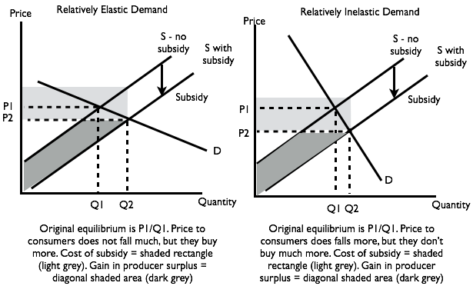  Benefits from a subsidy  Determined by relative levels of demand and supply elasticity  What is a price ceiling? Maximum price  Reason for price ceiling: Keep key products affordable to households on low incomes  Seven consequences of a price ceiling  1 Shortages – excess demand  2 Alternative rationing process  3 Consumers who receive product get consumer surplus  4 Decreased market size, low price limits supply  5 Deadweight loss – market operates below equilibrium quantity  6 Informal or black markets develop  7 Reduction in quality of products supplied – reward to suppliers is kept low  What is a price floor? Minimum price  Reason for price floor: Guarantee income (e.g. to farmers), secure supply, ensure a living wage  Four consequences of a price floor  1 Excess supply  2 Reduce market size because demand falls  3 Deadweight loss – market not at equilibrium  4 Informal markets – people work for less

ANSWER SECTION

TOPIC 1 – MARKETS – SUGGESTED ANSWERS
Question 1 – Data Interpretation
(a) The products are relatively scarce. Their production creates an opportunity cost as the resources used in production could have been used to make something else.
(b) There are buyers creating demand, sellers offering supply, products being offered for sale at set prices and retail outlets that allow buyers and sellers to interact. Buyers and sellers are free to trade or to opt out of the market. The market is competitive as there are other ways to buy the products. Consumers are making decisions that promote their satisfaction and the sellers have made decisions that will earn them a profit. When a product is purchased property rights are transferred from the shop owner to the shopper.
(c) When demand equals supply over a period of time at the prices being charged, the markets are in equilibrium. There will not be a shortage, nor stock left over. If non-price factors affect demand or supply for their products and unsold stocks build up or stocks are run low, they may alter their prices or aspects of their marketing and/or change the level of their supply.

Question 2 – Data Interpretation
(a) A factor of production is a resource input that enables production to take place. Factors of production are land, labour, capital and enterprise.
(b) Significant points include:
- There is a generally positive relationship between the two variables
- The global supply of rare-earth metals and the global demand for rare-earth metals both increased in each year in the data series except one.
- The trough for the global supply of rare-earth metals occurred in 2000 (at about 73 000
tonnes), while the trough for the global demand for rare-earth metals occurred in 2001 (at
about 75 000 tonnes)
- The peak for the global supply of rare-earth metals was expected to be in 2012 at about
190,000 tonnes, while the peak for the global demand was also expected to be in 2012 at
about 200 000 tonnes.
- The demand for rare earth metals usually larger than supply

(c)
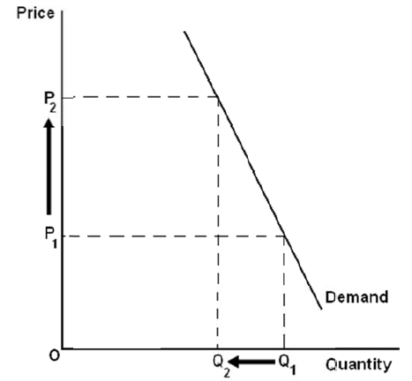

The demand for Chinese rare-earth metals is price inelastic because (i) they are an essential raw material in the manufacture of certain products and there are only a few other suppliers of rare-earth metals. This provides China with a source of monopoly power and creates conditions in which China’s government can restrict exports of rare-earth metals and bring about an increase in price.

Question 3 – Extended Answer Question
(a) Describe the main features of a market economy

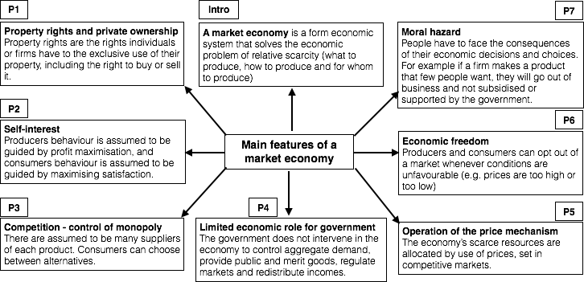

(b) Describe four situations were a market economy does not lead to an efficient allocation of resources.

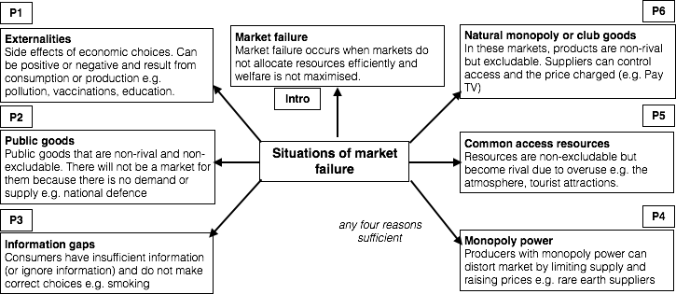

TOPIC 2 – DEMAND AND SUPPLY – SUGGESTED ANSWERS
Question 1 - Data interpretation
(a) Demand = quantity demanded at a given price level over a given period of time, supply = quantity supplied at a given price level over a given period of time.
(b) Concern about health, rising income, fashion, celebrity endorsement, availability of new products, scientific research.
(c) Big rise in demand, inelastic supply in short term leads to high prices. Prices may fall back later if demand drop and supply increases.

Question 2 – Extended Answer Question
Introduction | The market for bottled water allows consumers and producers to exchange bottled water. The market is disturbed by a decrease in demand for bottled water.
Body paragraph 1 | (S) The decrease in demand in reflected in a leftward shift in the demand curve for bottled water.  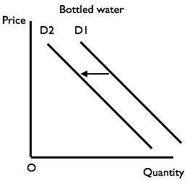  (E) At each price level there is a fall in the quantity demanded.
Body paragraph 2 | (S) The market is disturbed or knocked out of equilibrium by the fall in demand.  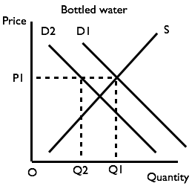  (E) At the existing price (P1) the market does not clear. There is now a surplus of bottled water available in the market (Q2 – Q1). Unsold stocks of bottled water will develop.
Body paragraph 3 | Sellers react to the build up in stock by reducing the price of bottled water. As a result of the price cut some consumers will be encouraged to re-enter the market and there will be an extension in the quantity demanded, shown as a movement along the demand curve D2. Sellers will reduce supplies and there will be a contraction in the quantity supplied, shown as a movement along the supply curve S.  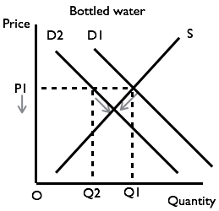
Body paragraph 4 | The extension in demand and contraction in supply erodes the surplus in the market until it disappears altogether at price P2. This becomes the new equilibrium price and the equilibrium quantity is Q3.  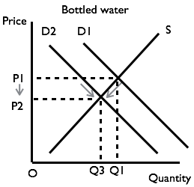
Conclusion | The size of the price discount will depend on the gradients of the demand and supply functions, in other words the price elasticity of demand and elasticity of supply.

TOPIC 3 – ELASTICITY – SUGGESTED ANSWERS
Question 1 – Data interpretation
(a) Price elasticity of demand (PED) is a measure of the response or reaction in quantity demanded to a change in the price of that product.
(b) Degree of necessity or urgency of demand, availability of substitutes, time to make a choice.
(c) As the price rises (i) some buyers opt out of the market (marginal benefit now less than price) and (ii) there is an increase in quantity supplied or movement along the supply curve (price higher than opportunity cost of working in busy area for more drivers).
(d) Charging different prices to different groups of customers reduces consumer surplus. The grey boxes indicate revenue (price x quantity) for each group.
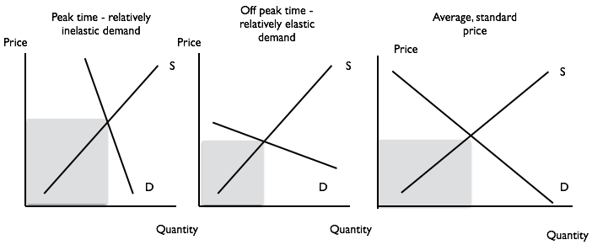

Question 2 – Data interpretation
(a) Blue (upward to the left) = demand; Red (upward to the right) = supply
(b) (i) Flower price: rise of 75% (54.5% mid-point method); Flower quantity: down 20% (22.2% mid-point method); PED = 0.26 (0.4 mid-point method)
(c) Revenue at price $20 = 20 x 250 = $5000; Revenue at price $35 = 35 x 200 = $7000.
Demand was relatively inelastic.
(d) Time, technology, regulations, costs of production.

Question 3 - Extended Answer Question
Title | (a) Explain why an understanding of price elasticity of demand and cross-price elasticity of demand may be important to a government. (12 marks)  (b) Explain why income elasticity of demand is a useful concept when explaining changes in the share of GDP of the service or tertiary sector in the economy.  (8 marks)
PART A  Introduction | Government needs to understand these elasticity concepts when undertaking aspects of its economic regulatory role.  Define price elasticity of demand (PED)  Define cross-price elasticity of demand (XED)
Body paragraph 1 | (S) One reason PED is important to governments is because it determines how much tax revenue they can expect to collect from indirect taxes.  (E) The more inelastic the demand for a good, the larger the tax revenue is likely to be.  (E) An example is indirect tax on petrol for which demand is relatively price inelastic.  (D) Draw diagrams to show government tax revenue is higher when an indirect tax is imposed on a good with inelastic demand. Explain the main points in the diagram
Body paragraph 2 | (S) One reason why XED is important to governments is because it helps them conduct competition policy and the control of monopoly power.  (E) XED reveals the extent to which products are substitutes or complements. When XED between two products is positive (>0) the products are substitutes. A merger or take over between two firms producing substitute products will reduce competition and increase monopoly power.  (D) Draw diagram to show impact on demand curve of a reduction in competition (i.e. draw it steeper and show revenue can be increased).
PART B  Introduction | Introduction: The share of GDP of different sectors in the economy changes over time (e.g. the rise in the service sector to about 80% of GDP in Australia)  Define the YED.  Define service or tertiary sector
Body paragraph 1 | (S) The services produced in the tertiary sector are generally income elastic (even more so than products produced in the secondary sector).  (E) This means that, over time as the economy experiences economic growth and incomes, demand for services increases.  (E) For example, people with higher incomes are more likely to employ mobile dog-washers than those on low incomes.
Body paragraph 2 | (S) International trade complicates the process of structural change, but income elasticity and the growth of incomes in other countries is still an important factor affecting structural change through the demand for exports.  (E) The service sector tends to grow relative to the secondary sector although this depends on the level of manufactured exports firms in the economy sell. The impact on the primary sector will depend on changes in the mineral and energy industries and in the demand for rural commodity exports.

TOPIC 4 – EFFICIENCY – SUGGESTED ANSWERS
Question 1 – Data interpretation
(a) Market efficiency occurs when resources are used in a technical and allocatively efficient way, i.e. costs of production are minimised (for a given quality of product) and consumers’ benefits match the level of producers’ costs. The economic problem is relative scarcity of economic resources compared to the level of needs and wants of members in a society.
(b) Upper triangle is consumer surplus, lower triangle is producer surplus.

(c) Some benefit is lost when there is underproduction. Deadweight loss erodes both community surplus when there is over production.

(d) Under-production may occur as a result of monopoly market power, regulated minimum or maximum prices, and regulated levels of output because a government withholds resources.
Over-production may occur if the government allocates resources (e.g. building coal-fired power stations in China), and when consumers ignore or don’t know about negative consumption externalities.

Question 2 – Data Interpretation
Table 1 |  |  |  | Table 2
Number of cows | Willingness to pay ($) | Consumer surplus |  | Price of sheep dip ($) | Quantity demanded
1st | 100 | 40 |  | 100 | 1
2nd | 90 | 30 |  | 90 | 2
3rd | 80 | 20 |  | 80 | 3
4th | 70 | 10 |  | 70 | 4
5th | 60 | 0 |  | 60 | 5
6th | 50 | 0 |  | 50 | 6
7th | 40 | 0 |  | 40 | 7
8th | 30 | 0 |  | 30 | 8
9th | 20 | 0 |  | 20 | 9
10th | 10 | 0 |  | 10 | 10
 | TOTAL | 100

(a) 5 cows, including the break-even cow; (b) See table 1; (c) $100; (d) 5 litres
(e) $120 (area of triangle below the demand curve)
(f) Cows are a discrete product – they can only be bought in whole units. A farmer can buy one cow or two cows but not 1.45 cows. The demand curve for cows is, therefore, a step function rather than a linear function. Sheep dip is a divisible product – it can be purchased in precise or exact quantities. You can buy 1 litre of sheep dip, 2 litres or 1.45 litres. The demand curve for sheep dip is, therefore, a linear function.
TOPIC 5 – MARKET FAILURE – SUGGESTED ANSWERS
Question 1 – Data Interpretation
(a) Negative consumption externality. Externalities are generated when the car is used.
(b)
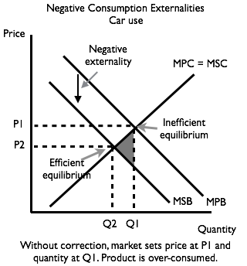
The loss of benefits (e.g. from extra fuel use and spending time in traffic jams) reduces the level of marginal private benefit.

(c) Car use can be reduced by (i) a congestion tax imposed when cars are driven into busy areas, (ii) by subsidising public transport and making public transport more efficient (e.g. through bus lanes); regulation (e.g. banning some cars on specified days); increasing the cost of parking.

Question 2 – Extended Answer Question
Title | (a) Explain the meaning of the term ‘market power’. (3 marks)  (b) Describe how a firm can acquire market power. (7 marks)  (c) Explain how market power can influence the level of market efficiency. (10 marks)
PART A | (A firm that has market power has some control over the price of its product and/or the level of supply of their product. The degree of market or monopoly power varies in imperfect markets and depends on the number of rival firms and the relative competitiveness of their products.
PART B  Body paragraph 1 | Firms acquire market power ‘organically’ from internal growth or through integration with other firms by mergers and acquisitions. Growth can be horizontal, where the firm integrates with firms producing similar products or at similar stages of a production process, and vertical, where the firm integrates with firms producing at different stages of the production process (forwards if firms operate further along the production process or backwards if the firms operate earlier in the production process.
Body paragraph 2 | Once a firm has developed some market power it can defend its producer surplus or monopoly profit by creating or exploiting barriers to entry. These barriers can take the form of branding, high spending on marketing, cost cutting through economies of scale in the long run, legal barriers in the form of patents and trade marks, control of supply, a high level of expertise, and goodwill from its customers.
PART C  Body paragraph 1 | Market power increases the price inelasticity of demand for the firm’s product. Its price making power allows it to restrict supply. Compared to a competitive market, the price increases from P1 to P2 and quantity supplied falls from Q1 to Q2. This allows the firm to increase its producer surplus at the expense of a reduction in their customers’ consumer surplus and s reduction in overall welfare (or deadweight loss).  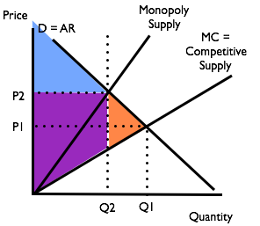

Question 3 – Extended Answer Question
Title | (a) Describe the market conditions that lead to a ‘tragedy of the commons’ (6 marks)  (b) With reference to a specific example of common access resources that are being overused, suggest two strategies to solving the problem and assess the effectiveness of these strategies. (14 marks)
PART A | A situation becomes a ‘tragedy of the commons’ when access to an economic resource (e.g. beauty spot, common land, the earth’s atmosphere) is non-excludable, i.e. there is open access to resource, and where use of the resource becomes rival, i.e. where one person’s use of the resource affects the level of benefit another person can receive from the resource. For example, open access to a national park may cause environmental damage and reduce the pleasure enjoyed by other users.
PART B  Body paragraph 1 | One example of an open access resource is the earth’s atmosphere. Negative externalities associated with climate change have grown as a result of the ‘free’ disposal of the by-products of fossil fuels into the atmosphere. Include a diagram showing the impact of negative production and or consumption externalities.
Body paragraph 2 | One strategy to reduce the problem is to develop a ‘cap and trade’ emissions trading system. This creates a parallel market in ‘permits to pollute’. It involves an assessment of the amount of greenhouse gas that the atmosphere can tolerate without raising the earth’s temperature too much and issuing an appropriate amount of permits. Paying for a permit and the right to pollute provides an incentive to producers to change their production methods and avoid polluting the atmosphere. Problems associated with this approach concern the efficiency of monitoring production process, assessing the amount of pollution that can be allowed and controlling the supply of permits.
Body paragraph 3 | A second strategy is to subsidise the development and use of ‘green’ fuels and ‘green products’ such as wind turbines and electric cars. The subsidy is funded by the government and paid for by taxpayers. Problems associated with this strategy are picking the right ‘infant’ green industries and products, deciding how much subsidy is needed and when it should be withdrawn, and persuading consumers to switch away from the polluting products that may still be cheaper and more convenient. (Note: There are other strategies that could be used such as (i) education and the encouragement of socially responsible behaviour and (ii) regulation.)

TOPIC 6 – GOVERNMENT INTERVENTION – SUGGESTED ANSWERS
Question 1 – Data Interpretation
(a) A price floor creates a minimum price in a market. This price is above the free market equilibrium price.
(b) To provide a ‘living wage’ to low paid workers so people do not fall below the poverty line and to compensate people for the impact of inflation on the level of real wages.
(c)
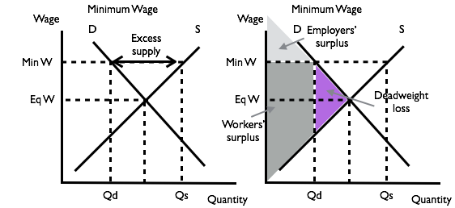
(d) ACTU places a relative high value on ‘equity’ and broader social factors. Growth in the economy (robust economic conditions) may push the demand curve for labour to the right, reducing the impact on unemployment. The ACCI places a relatively high value on market efficiency and the profits of its members.

Question 2 – Data Interpretation
(a) The law leads to extra demand because the price is below the equilibrium price but suppliers will be reluctant to produce sufficient eggs to meet this higher level of demand.
(b) BM P = possible black market price. Eq P – free market price. Max P = maximum price set by government.
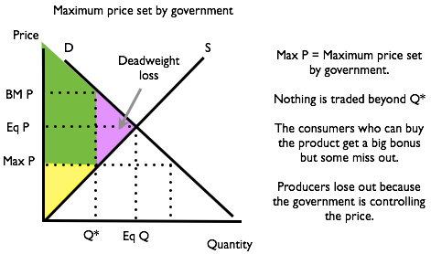
At the maximum price there is a shortage. Suppliers reduce supply because the reduced price doesn’t cover their costs of making some eggs. Deadweight loss is the area of the triangle that points to the free market equilibrium.
(c) The government may not be interested in maximum welfare. It may have a way of allocating the eggs rather than letting the market decide.

Question 3 – Extended Answer Question
Title | (a) With the use of a demand and supply diagram, describe how the payment of a production subsidy to producers in a market affects market equilibrium in that market. (8 marks); (b) Describe two benefits and two costs from continuing subsidy payments to car component suppliers in Australia. (12 marks)
PART A | Show that price falls to consumers and quantity of output increases. Good answers may compare the cost to government (light grey rectangle) and gain in producer surplus (diagonal shaped area).  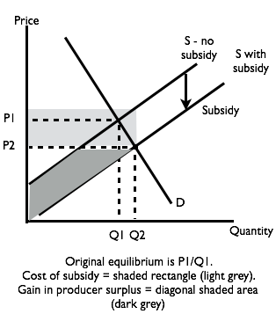
PART B  Positives  Negatives | 1. A subsidy would increase the international competitiveness of car-component producers in the short run. This would help protect up to 200,000 jobs.  2. Subsidy gives firms time to adapt (e.g. to become niche producers of elaborately transformed manufactured goods such as Bosch’s diode production.  1. Subsidies are expensive in dollar terms and in opportunity cost terms (the value of what is foregone as a result of the subsidy).  2. The subsidy would encourage other rent-seeking interest groups also looking from government support or protection.

Question 4 – Extended Answer Question
Title | (a) Explain the advantages and disadvantages of placing a price ceiling or maximum price for rental property in a town or city. (10 marks);  (b) Explain the advantages and disadvantages of increasing the minimum wage in an economy. (10 marks)
PART A: Intro  Body paragraph 1  Body paragraph 2  Body paragraph 3  Conclusion | Define price ceiling/maximum price. Define deadweight loss and total welfare.  Draw diagram for rental property market. Show on diagram the deadweight loss and reduction in total welfare  Describe the result of the price ceiling. There is excess demand and a shortage of rental properties.  Discussion of other factors including fall in quality of rental property, development of waiting lists and queues and emergence of black markets  Only works in short run. Creates long-run problems. There are other ways of increasing affordable rental property (e.g. social housing)
PART B: Intro  Body paragraph 1  Body paragraph 2  Body paragraph 3  Conclusion | Define minimum wage. Topical comment: Introduction in Australia.  Draw diagram for the labour market. Show on diagram the deadweight loss and reduction in total welfare.  Outcome is some workers receive higher pay but there is also a rise in unemployment (extra supply, lower demand)  Discussion about response of firms, e.g. some firms (e.g. shop owners) may be able to pass higher wages on to customers and look for cost savings (e.g. through introduction of new technology)  Creates unemployment. Better ways of helping low paid, e.g. using tax credits.

